**Name: Sriram M**

**Reg no:1919103121**

**Assignment-IV**

**Write code and connections in wokwi for ultrasonic. Whenever distance is less than 100 cms send “alert” to ibm cloud and display in device recent events.**

**Code:**

#define ECHO_PIN 2

#define TRIG_PIN 3

#define ORG = "5q4061"

#define DEVICE_TYPE = "US_Sensor"

#define Device_Id = "Y24V19_sensor"

#define AUTH_METHOD = "use-token-auth"

#define AUTH_TOKEN = "oW&W6IEIe2Zykab6St"

void setup() {

**Serial**.begin(9600);

 pinMode(TRIG_PIN, OUTPUT);

 pinMode(ECHO_PIN, INPUT);

}

float readDistanceCM() {

 digitalWrite(TRIG_PIN, LOW);

 delayMicroseconds(2);

 digitalWrite(TRIG_PIN, HIGH);

 delayMicroseconds(10);

 digitalWrite(TRIG_PIN, LOW);

 int duration = pulseIn(ECHO_PIN, HIGH);

 return duration * 0.034 / 2;

}

void loop() {

 float distance = readDistanceCM();

if(distance <= 100)

{

**Serial**.println("person detected ");

}

else{

**Serial**.print("Measured distance: ");

**Serial**.println(readDistanceCM());

}

 delay(1000);

}

**Simulation:**

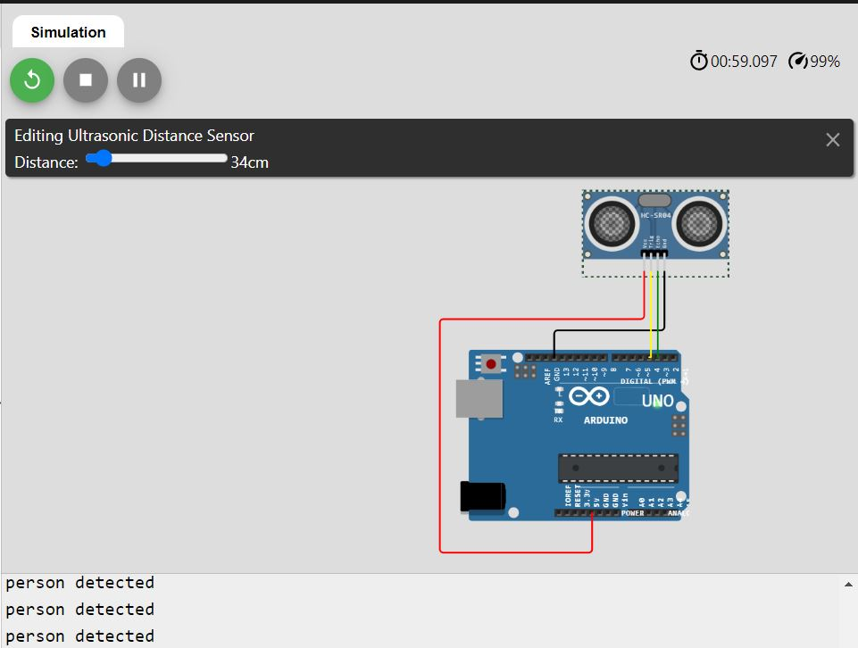

**Wokwi link:** https://wokwi.com/projects/346774428015657554

**IBM Cloud:**

